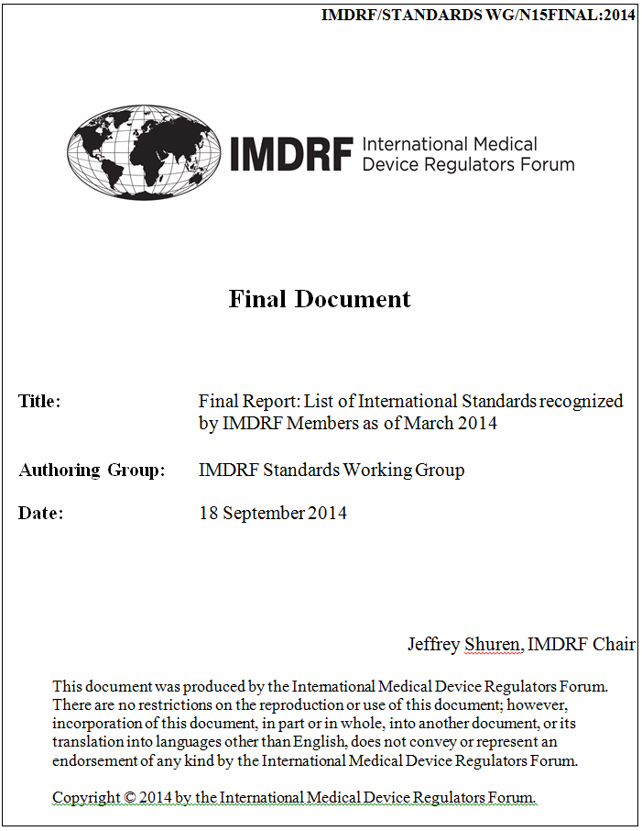

IMDRF/Standards/N15FINAL:2014

Final Report:
“List of international standards recognized by IMDRF management committee members” Current as of: March 2014

Dr. Matthias Neumann

Mandate

Gathering information and creating a list of standards used for medical devices regulatory purposes that are recognized by IMDRF Management Committee members

Background

The GHTF regulatory model is based on the principle that the regulation defines the essential principles for safe and effective medical devices.

GHTF/SG1/N044:2008: Role of Standards in the Assessment of Medical Devices

International Standards should specify (interpret) in detail how regulatory compliance (e.g. with the essential principles) for medical devices (processes or manufacturers) could be achieved.

Initiated Actions

1. Request for the nomination of national experts

2. Circulation of a list of 1102 valid international standards on Medical

Devices (ISO/IEC) to USA, Canada, Australia, Japan, Brasil,

China, Russia and the EU-Commission

3. Indication of the level of recognition of these standards (Y- fully recognized, N-not recognized, P-partially recognized or mandatory) by the nominated national experts

4. Compilation and assessment of the provided answers

An Excel sheet containing a list of 1102 IEC and ISO standards with
relevance to medical devices was developed.

Basis: database research covering the following ICS (International
Classification for Standards) notations.

• 11.100.20 (Biological evaluation of medical devices)
• 11.120.20 (Wound dressings and compresses)
• 11.140 (Hospital equipment)
• 13.140 Noise with respect to human beings. Including audiometry. Acoustics and acoustic measurement -> audiometer).

ICS (International Classification for Standards) notations.

• 11.100.10 (In vitro diagnostic test systems

• 11.080 (Sterilization and disinfection

• 11.040 (Medical equipment)

• 11.180 (Aids for disabled or handicapped persons)

• 11.060 (Dentistry)

For pragmatic reasons other medical devices (related) standards or standards of other international standardisation bodies have not been considered within this first phase of the project.

• All 8 IMDRF members provided input to the project

• a list with a clear indication of fully or partially recognized/mandatory standards was provided by 8 of the 8 regions/countries

• The number of fully recognized standards (out of 1102 standards)
varies between 261 and 44

• The number of partially and fully recognized standards varies between more than 390 and 44

• Three regions are using mandatory standards

Number of recognized/mandatory standards in IMDRF
jurisdictions

300

250

200
part.rec. and man.

150
mandatory

100
part. rec.

50 ful. rec.

0
USA EU Canada Japan Australia Brasil China Russia

Number of recognized/mandatory standards in IMDRF jurisdictions

 | recognised | partially | mandatory | partially recognised and mandatory
USA | 261 | 33
EU | 222 | 3
Canada | 181
Japan | 104 | 105
Australia | 44
Brasil | 102 |  | 78
China | 66 | 71 | 130
Russia |  |  |  | 239

• There are 2 standards which are recognized/mandatory by 7 of the
8 regions

Document reference | Publication | Title
ISO 14630 | 2008-01 | Non-active surgical implants_- General requirements
ISO 14971 | 2007-03 | Medical devices_- Application of risk management to medical devices

10

17 standards which are recognized/mandatory by 6 of the 8 regions
Document/reference | Publication | Title
IEC 62304 | 2006-05 | Medical device software_- Software life cycle processes
IEC 60601-2-20 | 2009-02 | Medical electrical equipment_- Part_2-20: Particular requirements for the basic safety and essential performance of infant transport incubators
IEC 60601-2-27 | 2011-03 | Medical electrical equipment_- Part_2-27: Particular requirements for the basic safety and essential performance of electrocardiographic monitoring equipment
IEC 60601-2-29 | 2008-06 | Medical electrical equipment_- Part_2-29: Particular requirements for the basic safety and essential performance of radiotherapy simulators
IEC 60601-2-39 | 2007-11 | Medical electrical equipment_- Part_2-39: Particular requirements for basic safety and essential performance of peritoneal dialysis equipment
IEC 60601-2-44 | 2009-02 | Medical electrical equipment_- Part_2-44: Particular requirements for the basic safety and essential performance of X-ray equipment for computed tomography
ISO 10993-1 | 2009-10 | Biological evaluation of medical devices_- Part_1: Evaluation and testing within a risk management process
ISO 10993-3 | 2003-10 | Biological evaluation of medical devices_- Part_3: Tests for genotoxicity, carcinogenicity and reproductive toxicity
ISO 10993-4 | 2002-10 | Biological evaluation of medical devices_- Part_4: Selection of test for  interactions with blood

11

17 standards which are recognized/mandatory by 6 of the 8 regions

Document /reference | Publication | Title
ISO 10993-6 | 2007-04 | Biological evaluation of medical devices_- Part_6: Tests for local effects after implantation
ISO 10993-12 | 2007-11 | Biological evaluation of medical devices_- Part_12: Sample preparation and reference materials
ISO 10993-14 | 2001-11 | Biological evaluation of medical devices_- Part_14: Identification and quantification of degradation products from ceramics
ISO 10993-15 | 2000-12 | Biological evaluation of medical devices_- Part_15: Identification  and quantification of degradation products from metals and alloys
ISO 10993-17 | 2002-12 | Biological evaluation of medical devices_- Part_17: Establishment of allowable limits for leachable substances
ISO 11137-1 | 2006-04 | Sterilization of health care products_- Radiation_- Part_1: Requirements for development, validation and routine control of a sterilization process for medical devices
ISO 14155 | 2011-02 | Clinical investigation of medical devices for human subjects_- Good clinical practice
ISO 17664 | 2004-03 | Sterilization of medical devices_- Information to be provided by the manufacturer for the processing of resterilizable medical devices

Findings

The use of recognized standards can be a tool for harmonising requirements on medical devices in the different IMDRF jurisdictions.

The concept of the use of recognized/mandatory standards is currently implemented in the different IMDRF jurisdictions in different ways.

1. Simple mechanisms to establish a non-binding list of recognised standards
2. “Translation” of the standards into national legislation
3. Focusing on standards which are used by the regulators to perform tests
4. Complex mechanisms to give a standard the legal status of a recognised, harmonised or mandatory standard.
5. Concentration on horizontal standards and product specific standards used for the assessment of high risk devices. (Since the assessment if standards are in compliance with the essential principles and the regional/national regulation is too complex and resource binding).

Discussion Points for Regulatory Authorities

Efficient development and use of recognised standards requires that regulatory authorities have the resources to:

- Be involved in standardization projects, and
- Assess and implement the recognised standards under national legislation

Considerations:

- limited resources (for the assessment, for the implementation into the nat. regulation, for contribution to international standardization projects), and

- limited influence of regulatory bodies on
standardization projects

Thank you

IMDRF Project:
“List of international standards recognized by IMDRF
Management Committee members”

Final Report

Some regions have recognized older versions of standards and are in the process of recognizing updated versions.

